# 4

# Notation and Representation: How We Get ’Em To Crack the Code

“In the beginning was the noise …” [7]

## Gateways, Barriers, and Boundaries

Music can and does exist without notation.  In fact, the existence of music predates what we have come to accept as traditional music notation.  Many musical traditions have thrived for centuries without any kind of formal codified symbol system to make musical replication easier. It has existed, and often still exists, as an aurally transmitted art form.

The same can’t be said for computers with regard to their underlying code.  Though the tongue-in-cheek Hart and Lieberman quote above [7] gets to the heart of the aural and intuitive nature of music’s origins, computers rely on complex mathematics built, amazingly, on the seemingly simple 1s and 0s of binary arithmetic.  Yet just as with music, there are tools and applications that your students can use to express themselves without even thinking about the underlying mathematics.  For many of your students, the act of creating, whether it’s making music or developing web content, is accomplished intuitively: without formal training and knowledge of the “tools of the trade”: musical notation and computer code.

Sherry Turkle [18] asserts that “today’s children are growing up in the computer culture; all the rest of us are at best its naturalized citizens.”   Following that line of reasoning a bit further, let’s assume for a moment that for your students music and computers are ingrained components of their culture.  As is sometimes the case, however, the formal acquisition of these tools can often serve as a barrier to further understanding rather than the gateway this knowledge is meant to serve: impeding rather than enabling the creative process.

Gardner [6] feels that formal musical training can “be the beginning of the end of most children’s musical development” [p. 38].  He believes “the challenge of musical education is to respect and build upon the young child’s own skills and understanding of music rather than impose a curriculum designed largely for adults” [p. 38]. Bamberger’s research with college students suggests that students of any age possess musical instincts that, in the proper environment, can be developed and nurtured [1].  One of your goals, then, might be to engage students in projects that help them to investigate the *why* and *how* of the symbol systems used in both fields, as well as to understand the boundaries imposed by these systems.   As suggested by Torff & Gardner [17], “People may be symbol-using creatures, but we do not know automatically how to make sense of symbols. We have to learn to read (decode) and create (encode) symbols. p98”

If musical notation isn’t necessarily intuitive to your students, how might you help them learn it in a way that builds on what they already know?  And rather than being an insurmountable impediment, how might you help them discover the necessity of creating a common symbol set while simultaneously recognizing its complexities and limitations? In this chapter we will explore one project’s evolution from its original simple acoustic inception through a variety of digital permutations and extensions.

## Found Instruments Project: Goals and Overview

The Found Instruments project within the context of a course designed for music teacher education is focused on helping students experience acts of music exploration, intuition, creation, and composing from the perspective of a child before the imposition of formal musical training. Gena typically assigns it to music education students in their General Music Methods class, but has used variations of it at a wide range of grade levels.

|  |
| --- |
| Dscn0224-cropped  *Figure 4-1.* Maggie chose to use   her steam iron as a found instrument. |

Students are asked to find typical household objects that can produce several pitches or timbres. They then fashion a “musical instrument” from these “found objects” and create a musical composition that adheres to a common musical form. Once the composition is crafted, students are asked to devise a system of creative/graphic notation to somehow “preserve” this piece of music for others to perform and enjoy.

Of course, with inexpensive, readily available digital technology, one could “preserve” the music simply by recording a performance. But the idea is to get your students thinking about how people would have done this *before* such technology was available and *before* a formal notation system was in place. For many students, learning musical notation can be an impediment to music making. The Found Instruments project encourages students — particularly those preparing to be teachers of music — to think about how a total novice goes about learning a new symbol system. Through this activity, students begin to appreciate the relative simplicity of traditional music notation. They begin to comprehend the difficulties in creating a universal symbol system designed to transmit a variety of dynamic data: one that transcends languages and cultures.

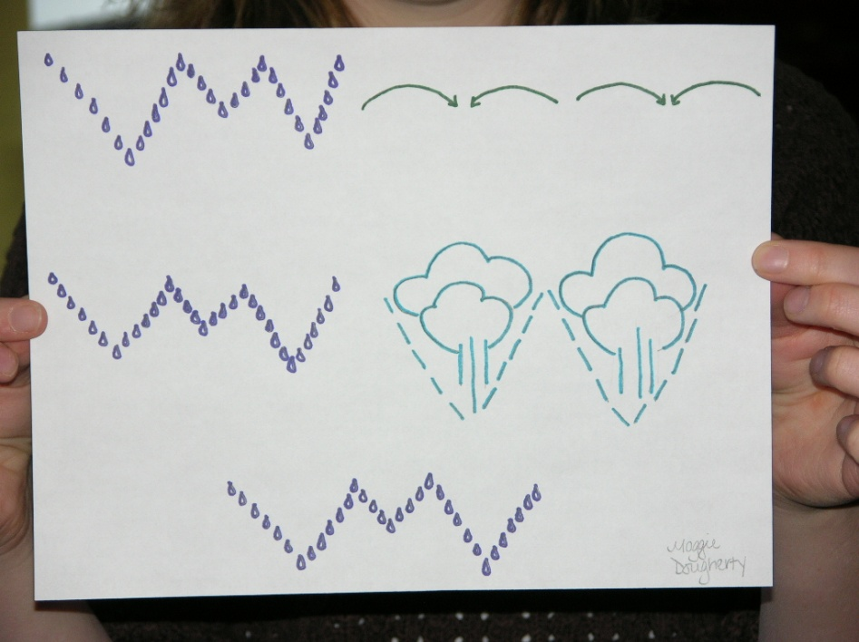

*Figure 4-2.* Maggie’s notation for playing her steam iron.

## A Bit of Background

Of course experimenting and creating music with found sounds, as well as the use of invented notation, is by no means a new or novel practice. As composers in the early 20th century began to expand their aural palette beyond traditional musical instruments and musical structures by using found sounds and electronically generated sounds to augment more conventional ones, the need to find alternative modes of representation formed the basis for what we generally refer to as invented or graphic notation. In fact, this practice still continues. Found sound compositions continue to make their way into today’s concert halls such as “Kraft” written by Magnus Lindburg in 1980 and recently performed by the New York Philharmonic, and “Junkestra” written by Nathaniel Stookey, and performed by the San Francisco Symphony [[9](#_ENREF_9" \o "Katz, 2010 #56), [16](#_ENREF_16" \o "Tommasini, 2010 #55), [20](#_ENREF_20" \o "Wakin, 2010 #60)]. In both cases various members of each orchestra scavenged local garbage dumps and spend time exploring the various pieces of garbage for “percussion instruments” that produced just the “right” sounds. Not surprisingly the seeds for Tod Machover’s [1]inclinations towards creating music using traditional western musical instruments as well as a greatly expanded sonic palette were planted in his youth by his mother [[10](#_ENREF_10" \o "Machover, 2011 #62)]. As a toddler, through his mother’s encouragement to find music within his house, he learned the basics of music composition.

Each week, we set out on expeditions of her dvising, dicovering

household objects that made interesting sounds that could in turn

be combined to create new textures, emotions, and narratives.

Then followed the task of making a “picture” of our new compostion

so that we could recreate it the following week. I learned to invent

music from these frist principles: sound, structure, score. [[10](#_ENREF_10" \o "Machover, 2011 #62)]

The more traditional approach to music teaching generally begins with a series of learning objectives based around concepts that are unfamiliar to most students - traditional notation- as well as skill building on traditional musical instruments, which may also be unfamiliar territory to many students. Beginning with non-traditional objects for music creation encourages students to better explore the sonic potential of materials not generally associated with musical creation. The novelty of the objects, offer students an opportunity to explore and demonstrate a variety of ways to ‘play’ them [21].

In the late 1960’s, starting with” the Comprehensive Musicianship Project [5, 11], a small group of musicians, composers and educators began to advocate for the inclusion of musical composition and improvisation into the more performance oriented music curriculum. Many educators and composers at that time proposed that children needed to explore properties of sound and construct their own symbol systems in order to make meaning of what they are intuitively hearing [2, 3, 4, 13, 19]. This was in response to the traditional view of music education where, as both Bamberger and Benson [2, 4] contend, the learning of musical notation is given “privileged status” in the curriculum, minimizing the importance of other aspects of music making. As Ronald Thomas [15] wrote in *MMCP Synthesis: A Structure for Music Education;*

…mastery of notation, a complex system of symbolism for the transcription and recall of notes, can so dominate the study that the reason for the symbolism becomes obscured. Note reading is substituted for conceptual understanding, and rhythmic computation, often divorced from a musical context, becomes a major activity (p.4).

Benson [4] offers two sound reasons for not emphasizing traditional notation when first introducing creative composition activities to children. The first is to remove any advantage that students already knowing notation might have over those who don’t. The second one, which gets closer to the heart of the problem-solving nature of our work, is that it enables students to give serious thought to how best to represent their work.

There are several caveats with regard to your students’ invented notation systems. First, it should not resemble standard musical notation in any way, shape, or form. For music majors, this requires a great deal of “letting go” of learned habits. Second, the notation system should be able to be understood with little or no verbal or written direction. In reality, as your students will be quick to point out, there is a great deal of direction with regard to the learning and interpreting of notation, but the idea here is to build on what each of them believes would be intuitive. Third, you must lead them to believe that they will be performing their own composition for the class.

This is where the “Gena Twist” comes in. Your students will come to class eager to demonstrate what they’ve created. Instead, ask them to hand over their found instrument and composition to a classmate who will explore it and perform the composition for the class *with no explanation from the composer*. What’s the point you ask? If your students first performed their own piece and then had someone else perform it, you would not readily know what was intuitive and what was remembered from the composer’s performance.

The element of surprise presents a kind of challenge. Who will and will not “get” what the composer/creator intended? The “twist” is what gets to the heart of the project and gently prods the performer into analytical and critical thinking mode, foundational elements of computational thinking (CT). To decipher (or interpret) another student’s symbol system, students must posit hypotheses about the symbols’ meanings and then test the efficacy of those hypotheses. These are two of the basic steps in all scientific and mathematical problem solving.

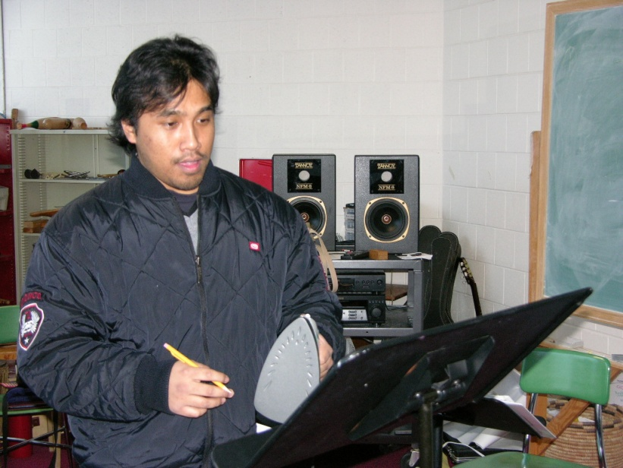

*Figure 4-3.* Sophanna attempting to play Maggie’s steam iron.

This project will pose some interesting questions for your students. Music is about sound and exists in space and time, but notation is static and two-dimensional. Therefore, what symbolic representation will best convey the musical action you intend with respect to rhythm, pitch, duration, dynamics, or timbre? What other important attributes of the sound are you looking to convey? How can you best represent those?

As one of our students pointed out:

… for students to truly comprehend standard musical notation, they must first create their own. Through that creativity and exploration, they will make the connections necessary to bridge the gap between their own creations and standardized music notation.

Another student suggested that “playing other people’s instruments really made us think analytically and creatively about figuring out how to ‘break the code.’” This experience, in fact, helped students reflect on the choices they made with regard to their own representations. A third student likened learning notation to learning a foreign language:

I think we were asked to play each others’ instruments so we could get an idea of what it feels like again to have to read a foreign language. When beginner students are asked to read music, they are basically doing just that, and once the skill is developed [they] can read fluently. The same goes with our compositions.

## Synchronized Class Version

### Part 1: The Music Assignment

The Found Instruments project has now had several permutations. For our synchronized classes we paired music education majors with computer science [17] majors for a joint project while the two groups of students were still in independent classes. The first axiom of interdisciplinary projects done with independent classes is that both sets of students must have equal “buy in.” That is, both must have an equal commitment to the project, or at least to the part for which they are responsible. The second axiom is that both sets of students must understand the *entire* project.

To address these issues, first make it clear that the students’ work in each class will be evaluated, even though those evaluations may differ significantly. In our case, the Found Instruments project was only a small part of the music course, while the implementation of the music students’ notations was the major part of the CS course, which focused on graphical user interface (GUI) programming. This dichotomy caused some problems. Second, schedule a number of joint classes in which your students can work together and get to know each other. We had five such classes during the semester.

Based on our experience, we would suggest that you use the first of those joint classes to introduce the project to both the music and CS students at the same time. You may also wish to consider structuring the project in two phases. Have your music students develop their found instruments, compositions, and notations in Phase I, and have your CS students recreate those notations as computer applications in Phase II.

One way for you to get both sets of students involved with the project early on is to require *all* students to come to class with some kind of household object that could produce several different sounds in terms of either pitch or timbre. We found this to be a great ice-breaker. After each student demonstrates his or her found object and the sounds it can make, have them form “ensembles” and play their objects in a spontaneous musical composition. To avoid intimidating technical students, group each such student with a couple of music students. The support each gives the other will help create an atmosphere of trust within the group.

In our class, we discovered that the CS students were very well able to hold their own during the group performances! In Figure 4-, the student in the middle is a music major, while the other two are CS majors. In Figure 4-, the two women are music majors, while the man is a CS major.

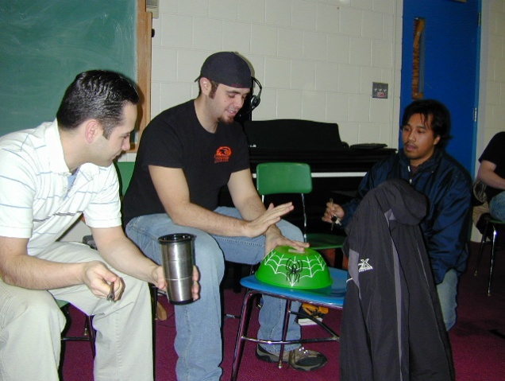 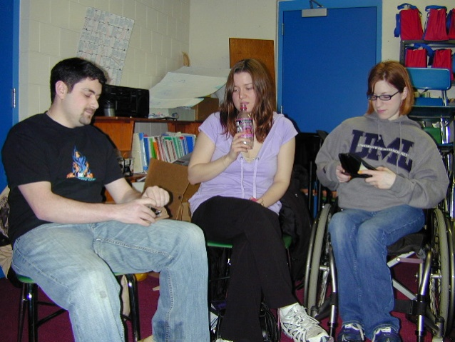

*Figures 4-4 and 4-5.* Students playing their found instruments in ensembles.

For your second joint meeting, have the music students bring in their full-blown creations and notations. While they will know in advance that they will be giving their notations to the CS students to perform, the CS students will be expecting to merely observe this class to gain insight into the programs they will be creating as a result.

Will the music students be able to separate themselves enough from their musical training and embrace the perspective of a non-musician with respect to their invented notations? Conversely, will the CS students be able to write an application that makes intuitive sense to a non-CS student? By placing both sets of students in the role of a novice, you require them to intuit a symbol system, much the way children learn to read music or learn a new computer application. Concepts that are taken for granted or considered “obvious” to one group are not necessarily intuitive or easy to grasp for the other. Formal, disciplinary-specific training can give students “tunnel vision.” One of the major goals of interdisciplinary projects is to break down the barriers that prevent students from understanding the perspectives of those not trained in their subject area, and one way to achieve this is to get them to think about novice perspectives.

The appendix to this chapter shows some of the other notation systems that our students developed for their found instruments.

### Part 2: The CS Assignment

In part 2 of the adaptation, ask your CS students to bring these instruments and notations to “life” in a computer-based environment similar to traditional computer-based notation programs.  While your music students explore the intricacies of instrument creation and notation systems, your CS students explore user interface components and techniques such as menus, toolbars, drop-down lists, and particularly approaches to implementing drag-and-drop, with an eye toward creating interfaces that are as easy to use as possible.

The ease-of-use goal is a critically important one. It is this goal that brings the assignment full circle back to the music students. As your CS students develop their programs, they periodically get to test their usability by having their music student partners attempt to use them (see Figures 4- and 4-). Such usability testing provides important insights into interface design that are impossible to gain by asking another CS student or professor to try to use the program. The interface must be tested with someone who is a member of the target user population. This is where most of the interdisciplinary student interaction takes place. In addition, repeated testing keeps program development on track and results in incremental improvements that will eventually lead to a polished product.

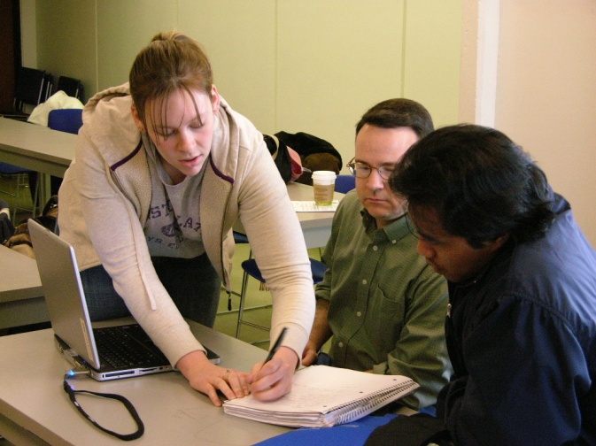 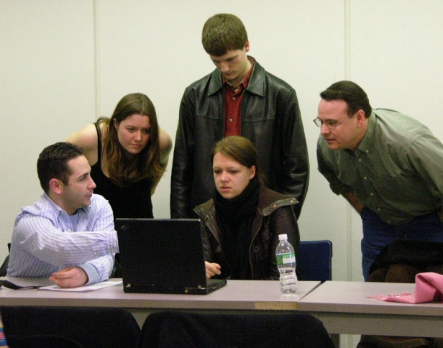

*Figures 4-6 and 4-7.* Music students reviewing CS students’ early efforts   
to write composing programs for their creative notations.

The CS students in our class commented that the “music students were more interested in the outcome [than the art students in the previous semester] and more excited about what we did with their notations.” The CS students also “enjoyed being exposed to music concepts that they wouldn’t have any insight into.” Among the issues that popped up were how to represent silences (rests) and how to design the user interface so that it made sense to people firmly rooted in standard music notation.

One of the most successful computer implementations of a music student’s creative notation was created by a CS student in conjunction with a music student who used his jacket as a found instrument. Figure - shows Mike playing his piece, while Figure - shows his notation.

|  |  |
| --- | --- |
| *Figure 4-8*. Mike playing his original *Eine Kleine Jacket Musik* on his jacket. (A video of Mike performing his original *Eine Kleine Jacket Musik* can be found at http://www.youtube.com/ performamatics#p/u/10/iD4dEZOTiIg.) |  |



*Figure 4-9.* Mike’s creative notation for playing his jacket.

The next six figures give a feel for the music composition program that Chris created for Mike’s notation. It is interesting to note both the pros and cons of this program from a user point of view. First, in Figure -, we see the toolbar at the left of the window. The icons were captured directly from Mike’s original, hand-written notation. Note in particular the last icon: a blank. This was added after the initial usability test to satisfy the need for notating a rest.

Figure - shows the program after a number of icons have been dragged onto the left-hand and right-hand “staffs.” Icons can also be added by double-clicking them, in which case they will be added to the right of the last icon added or the currently selected icon. (More on selecting icons in a second...)

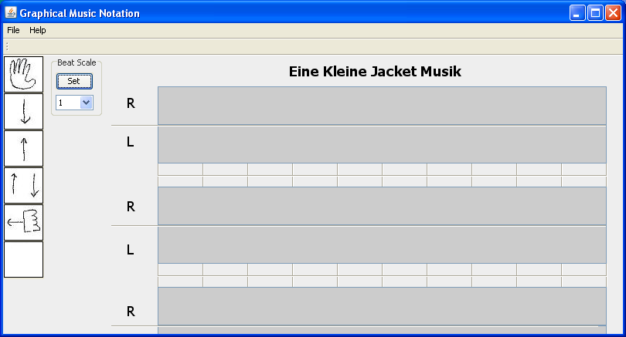

*Figure 4-10.* Program for composing jacket notation (step 1), showing the icon toolbar and a series of right- and left-hand “staffs” grouped into “systems.”

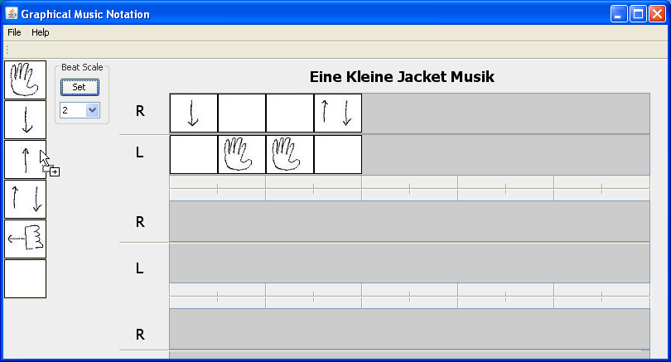

*Figure 4-11.* Program for composing jacket notation (step 2), showing icons added to the first “system.”

In Figure -, the user has “selected” the sixth icon in the left-hand staff of the first system. Note the cursor that appears to the right of this icon to indicate the next logical insertion point. But the user isn’t going to insert another icon, he’s going to delete the currently selected one by pressing the Delete key.

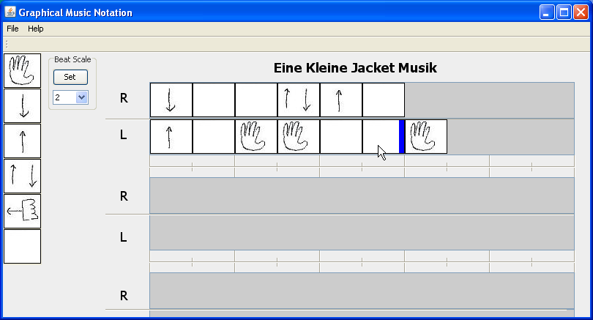

*Figure 4-12.* Program for composing jacket notation (step 3), showing the result of clicking the sixth icon in the left-hand staff of the first system to “select” it.

The result of that action is shown in Figure -. *Note the loss of the insertion point cursor.* In Figure -, the user is about to add a new icon immediately after deleting one. Figure - shows the result of that operation.

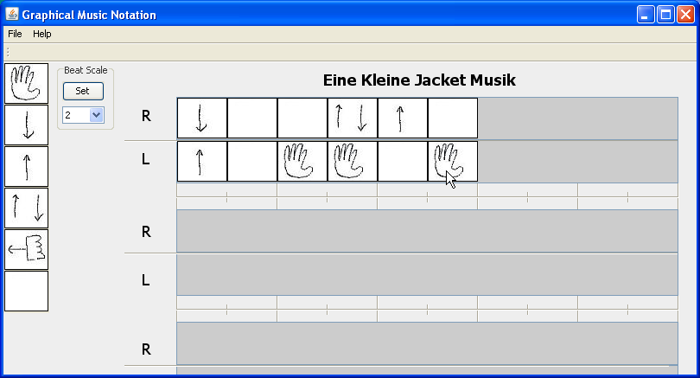

*Figure 4-13.* Program for composing jacket notation (step 4), showing the result of pressing the Delete key when the program is in the state shown in Figure -12.

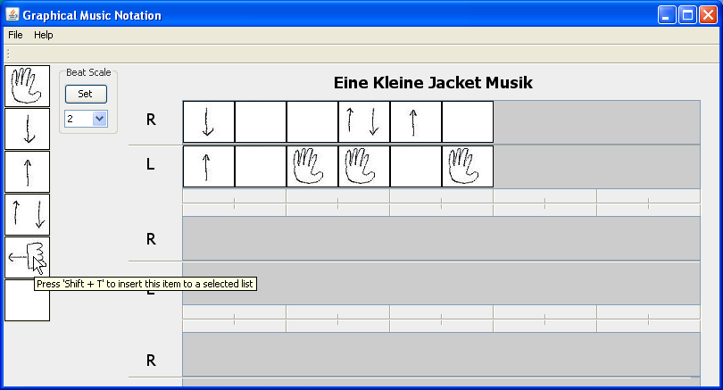

*Figure 4-14.* Program for composing jacket notation (step 5), showing the user about to add a new icon after performing the deletion in Figure -13.

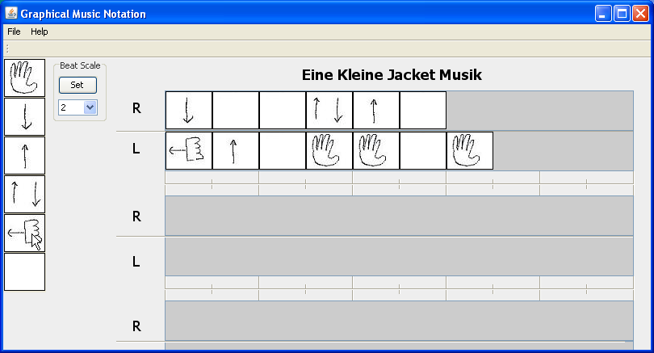

*Figure 4-15.* Program for composing jacket notation (step 6), showing the result of adding the icon indicated by the mouse pointer immediately after the deletion.

Where was the new icon added? Not where it was expected! The icon was added at the *beginning* of the staff on which the user had been working, not at the cursor position, where it should have been added. This is a user interface programming bug that provided us with a wonderful “teaching moment” when it totally confused the music students!

As this project was nearing completion, the music students were coming up with ideas for incorporating another project with the CS students into our coursework. This represented a complete turnaround in their attitudes, since they began our collaboration with a great deal of skepticism. As suggested by Seifert & Mandzuk [14], “…learning communities do not happen automatically.” In our case, the shared planning and class times were instrumental in helping our students bond and take ownership of the group experience.

## Hybrid Class Version

### From Two Parts to Three

The goal for the first half of our interdisciplinary, “hybrid” *Sound Thinking* course — the general education (GenEd) version with two professors in the classroom throughout the semester — was to introduce students to the idea of initially playing with, representing, and then manipulating sound both acoustically and digitally.  In planning the Found Instruments project for this class, we needed to rethink the computer-based component.  As we will discuss in Chapter 7, outcome expectations in a GenEd course are vastly different from those in a course for majors from a single discipline, even when the GenEd class is heavily populated with majors from mostly two disciplines: music and CS.  Our projects and assignments need to allow students from *any* discipline to be successful in *all phases* of the project. Therefore, unlike the two distinct parts of the Found Instruments project in the synchronized classes, we reconfigured the project so that all students could participate in all phases.  We also want to expand on the idea of invented notation as something that composers and performers are still grappling with. That is, we want to stress that this is not just an academic exercise.

In planning your interdisciplinary course, whether you intend it to satisfy general education requirements or not, we suggest breaking the project into three parts.  In part 1, your students should work individually as in the synchronized class version, creating compositions, coming to class prepared to perform their own compositions, and then being informed that their pieces would be performed by another member of the class.  In part 2, have students record their “instruments” and load their recordings into Audacity so that they can edit, manipulate, and process them into a completely new composition.  In part 3, have each student create a notation for another student’s manipulated composition.

A subtle benefit of part 2 in this project is that it allows you to introduce digital musicianship (using Audacity) early in the semester and within the context of a project rather than as a stand-alone activity, which will be less effective. As was noted by one of our students who is not a big fan of technology:

In creating a new, digital version of my found object composition, I definitely learned how amusing it is to explore the things one can do with sounds. It is hard to imagine what something would sound like reversed until you hear it, but Audacity helped a lot in that case.

Figure - shows a screen capture of one student’s Audacity project. Note the repetitions of individual sounds that were recorded from his found instrument.

During part 3, the performance class, an incident took place that well illustrates the unexpected dynamics of the hybrid course environment. After one of the performances, Jesse innocently asked the students, “What did you like about what you just heard?” Gena immediately retorted, “Jesse, I can’t believe you just asked that!” [2] As she not too subtly pointed out, Jesse’s question was judgmental and one that doesn’t

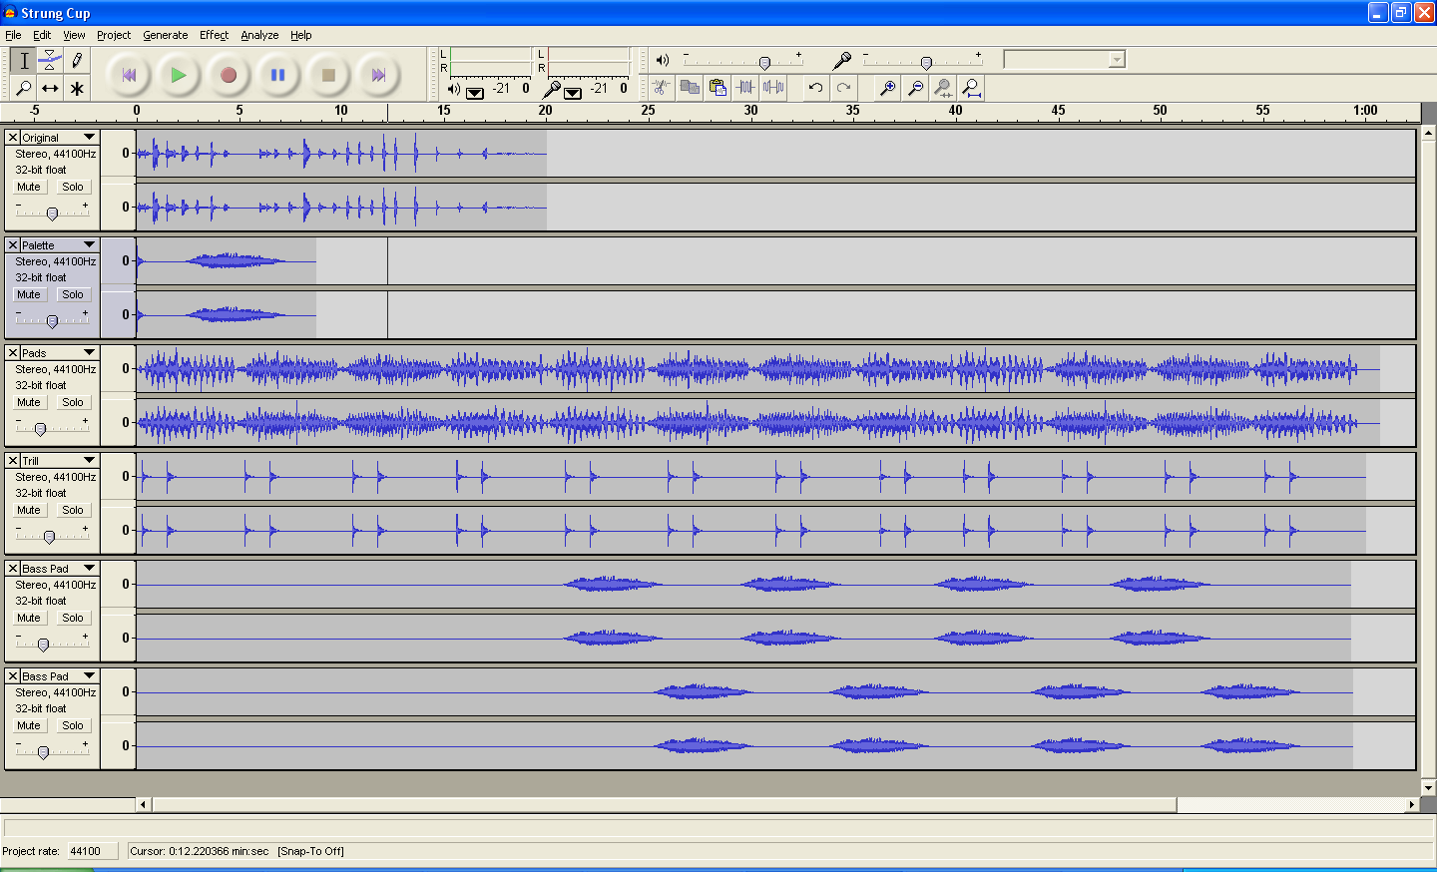

*Figure 4-16*. Sounds generated by a student’s found instrument as loaded and manipulated in Audacity.

always provide constructive criticism. A rather lengthy discussion ensued about how we should try to pose questions that will elicit thoughtful analysis rather than just whether one likes or doesn’t like a composition or performance. After all, when someone puts themselves out there creatively, do we necessarily want to shut them down with issues of likes and dislikes which suggest it’s either “right” or “wrong”? This is an area in which music education students need to be particularly mindful. Were our philosophies and teaching styles clashing? Or was this truly a teachable moment?

Part 1, in which students were composing and creating original notation, brought to light Bamberger’s observation that “our units of description come perilously close to becoming our units of perception — we hear and see what we can say.” [1] Students tended to default to simpler pieces they felt they could more easily notate. In many of the journal reflections and follow-up class discussions, students mentioned how they had come up with some complex compositions but could not figure out how they would portray their ideas through notation.  Comments like this were common and confirmed our initial instincts regarding *unlinking* the composition from notation:

When creating the new composition, I felt more free to get elaborate and not worry about how to notate. It was freeing to know afterwards that it wouldn’t be my job to figure out how to relate the piece. Overall, I think everyone was much more creative.

In part 2 we wanted students to put all of their creativity into playing with the sounds, so no notation was required.  Another student remarked:

When I first started composing, I began thinking about what the notation would look like, and I really had to force myself not to think in that fashion and focus more on how I wanted it to sound. Not knowing what the program could do, this was actually a little difficult, but once I got exploring and let go of the idea of notation it was much easier.

The sound manipulation activity was quite successful on a number of levels. This statement sums up what many students felt:

I learned how to use a new computer program (new to me at least), how to manipulate sounds, and how to notate a piece by listening carefully and repetitively (but notes help a whole bunch).

One student noted the enjoyment of manipulating sounds, though recreating his found objects piece came with some level of frustration.  He discussed having to start over several times, but then noted:

As frustrating as it was, I do not believe my piece would have come out as good as it did if I didn’t redo it a number of times. Each time I restarted I had a new perspective and was able to think of better ideas and new ways to approach my piece.

The act of analysis and revision is a very important part of the composition process and one that is often difficult to motivate students to do. Creating music with technology will afford your students instant aural feedback and allows for a great deal of exploration.

In part 3, which was announced after the completion of the digital compositions in part 2, students paired up so that each created the notation for his or her partner’s composition (see Figure -17). This activity generated a great deal of interest and engagement in the act of critical listening on a level that was much deeper than we would have anticipated.  As one student noted in his reflection, “This process forced me to listen actively (this includes interpreting the sounds in a way that others can understand).” He went on to discuss his thinking process:

I don’t know why I choose one thing over the other — I just picked what seemed most natural to me, hoping others would understand … looking back on my final draft, I felt like the notation represented the music rather well (sometimes it’s best to think with your senses and intuition).



*Figure 4-17*. Mary Ellen’s notation for Brittany’s composition.

Another student observed:

I really liked that we did the notation process this way, writing for someone else’s piece instead of your own. I feel like if I had written for my own piece, I would’ve been stuck on my original notation and — having created the piece — I wouldn’t have been able to listen to it objectively and take the sounds in differently. Working with someone else’s piece allowed me to start from scratch, listen actively, and create.

Part 3 actually had students applying skills from previous activities in terms of categorizing sounds to represent them. A student wrote:

Coming up with notation for a piece I was not intimately familiar with was a huge challenge. I could not really even start until after I had listened to it a dozen times, just to get a sense of it and start to hear the different layers. I started to be able to categorize the sounds, hearing the bubbles, the scratches, the hums.

### From Exercises to Music

It was during the part 3 activity that we really began to witness the seeds of computational thinking taking hold. All the students were exploring more. They were thinking about music and sounds differently and listening more critically.  Without realizing it, they were engaging in musical analysis in the most fundamental ways. They were going through the mental processes of organizing their thinking and coming up with a plan.

Now we needed to somehow tie this back to the world of music.  As luck would have it, we were both attending a concert by the JACK Quartet, a group of young string players who specialize in contemporary music (see Figure - and www.jackquartet.com). Since this concert was in an intimate venue, we could see some of the music, which looked suspiciously like invented notation (see Figure -).  Helmut Lachenmann, the composer, was present and spoke about his music, the sounds he was looking to create, which were non-traditional, and the manner in which that information was conveyed to the performers.  This prompted us to think about spending a little time on the idea of musical notation, its beginnings, and some of the ways contemporary composers have found traditional notation limiting.

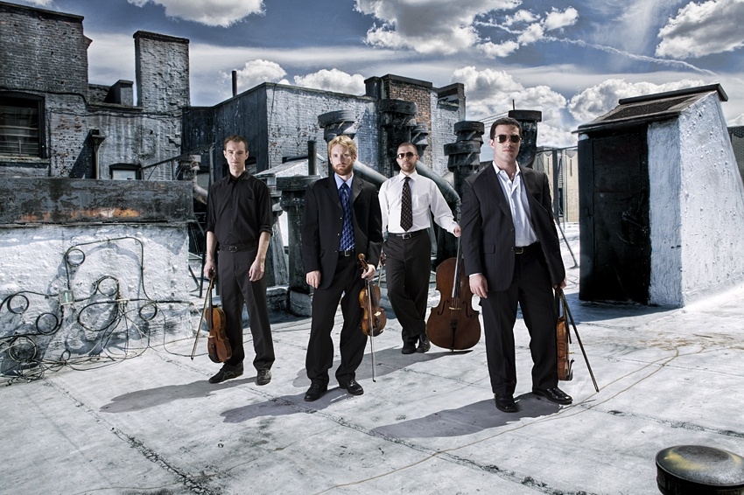

*Figure 4-18*. The JACK Quartet.

Copyright © 2010, JACK Quartet. Reproduced with permission.

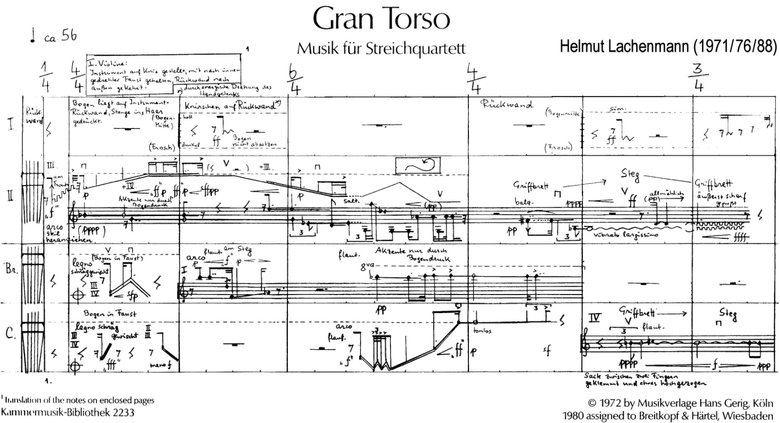

*Figure 4-19*. Excerpt from *Gran Torso* by German composer Helmut Lachenmann, demonstrating creative notation being played today by the JACK Quartet.

Copyright © 1980, Breitkopf & Härtel KG, Wiesbaden, Germany.

Reproduced with permission.

New music is often presented in a manner that can be off-putting to the novice listener. However, breaking down the composition and comparing aspects of the modern composition with musical elements students are familiar with can help students to listen with a more open mind. Engaging the students with performers, who are generally eager to share their musical world with others, can be an extremely valuable learning experience. As a resource, college music departments can be a treasure trove of performers, both students and faculty, with expertise in non-traditional forms of music making.

In our case, we were fortunate that Ari Streisfeld, one of the JACK Quartet violinists, was in the midst of working on his doctorate in performance practices at a nearby university. We approached Ari after the concert and invited him to give a presentation on his music to our class. He readily agreed. Ari began his presentation by demonstrating the many ways in which one could interpret a classical composition by Bach even though it is written in traditional music notation. He then compared it to several contemporary compositions and explained how he goes about interpreting less traditional forms of notation.

One student in the class was transformed by this. She commented:

I found that whole learning experience very intriguing and I am itching to learn more about it. I am currently doing some more research into this style and have found some great compositions, like *Sonata V* by John Cage. Ari’s presentation opened up a whole new world to me that I did not know existed and I want to share it with others.

The students were once again thinking and hearing differently. Another student wrote in his journal:

Ari’s presentation was definitely an experience I’m glad to have had recently … it definitely made me look at conventional instruments and alternative sounds that can be created with them. It was also interesting to see how a musical notation can rarely show exactly how a composer envisions their piece to be performed. There is only so much that can be explained this way. The rest is up to the performer.

Yet another student commented that “Streisfeld’s time with us ... was valuable as he showed us the farthest extremes of creative sound, and [gave us] a glimpse into the rules that can be broken to do so.” We could talk about this, they could read about this, they could even do their own experimenting, but seeing and hearing an accomplished musician demonstrate these concepts helped to validate their own experiences and realizations.

## Theme, Variations, and Computational Thinking

As you can no doubt see, there are enough variations on this project to engage a diversity of student populations and interests. But we still expect that you will be able to devise new twists that haven’t yet occurred to us. Even if you are not yet in a position to engage a colleague in collaborating with you on an interdisciplinary course, perhaps you will find some aspect of our experience worth looking into with your own students, getting them to explore and think creatively about sound and how to represent it in new ways.

The key to crafting learning activities is to weave them together so that each reinforces and builds on work that has gone earlier. In a participatory course like *Sound Thinking*, where students tend to have a lot of fun, it is easy for them to lose sight of the learning objectives and *why* they’re doing certain exercises. That’s not necessarily a bad thing. Carnegie Mellon professor Randy Pausch referred to such diversions as “head fakes” [12]. And the quote from MIT professor Harold Edgerton cited in the previous chapter is relevant and worth repeating here as well: “The trick to education is to teach people in such a way that they don’t realize they’re learning until it’s too late” [8].

But while it may be OK for your *students* not to see the big picture — well, at least not *initially* — it’s crucial that *you* keep the big picture in mind, and that big picture is computational thinking. To maintain that focus, have students write reflections on each activity recounting what they learned. Share these reflections in class to stimulate discussion of the activities’ underlying principles. Analysis and the application of logic are a large part of CT.

Another way to reinforce CT is to have students rate the degree to which a student’s performance matched the intentions of the composer. Be careful here: we are *not* suggesting that you have students rate each other’s performances, and we are *not* suggesting that they rate the quality of either the composition or the performance. Rather, we are suggesting that they rate the congruence between what the composer wanted to convey in the notation and what the performer perceived. To do this, students must develop a set of criteria — what some would call a *rubric* — by which they can evaluate the degree of agreement. If they establish criteria, assign weights to them, and then score each composer/performer pair and multiply by the weights to achieve a weighted average, they will indeed be practicing computational thinking.

## Bibliography for Chapter 4

[1] Bamberger, J. (2003). *The Development of Intuitive Musical Understanding: A Natural Experiment.* Psychology of Music **31**(7):7-36.

[2] Bamberger, J. (2006). *What Develops in Musical Development?* In G. MacPherson, ed. (2006). *The Child as Musician: Musical Development from Conception to Adolescence*. Oxford University Press: Oxford, U.K.

[3] Barrett, M. (2001). *Constructing a View of Children's Meaning-Making as Notators: A case-Study of a Five-Year-Old's Descriptions and Explanations of Invented Notations.* Research Studies in Music Education **16**:33-45.

[4] Benson, W. (1973). *The Creative Child Could Be Any Child: Drawing Out Inherent Creativity in Compositional Experiences.* Music Educators Journal **59**(8):38-40.

[5] Dello Joio, N., Mailman, M., Halgedahl, H., Flethcer, G., Beglarian, G., & Wersen, L.G. (1968). *The Contemporary Music Project for Creativity in Music.* Music Educators Journal **54**(7):41-72.

[6] Gardner, H. (1992). *Do babies sing a universal song?* In B.L. Andress & L.M. Walker, eds. (1992). *Readings in Early Childhood Music Education*. MENC: Reston, VA. p. 32-38.

[7] Hart, M., & Lieberman, F. (1991). *Planet Drum: A Celebration of Percussion and Rhythm*. Petaluma, CA: HarperOne.

[8] International Institute of Photographic Arts (2010). *Harold Edgerton*. <http://www.iipa.org/permanent/> haroldedgerton/bio.html *accessed* 7/16/2010.

[9] Katz, L. (2010). *Junkestra Symphony is Pure Garbage*.

[10] Machover, T. (2011). *Objects of design and play: my cello*. In S. Turkle, ed. (2011). *Evocative Objects*. MIT Press: Cambridge, MA. p. 12-21.

[11] MENC (1973). *Contemporary Music Project.* Music Educators Journal **59**(9):33-48.

[12] Pausch, R., & Zaslow, J. (2008). *The Last Lecture*. New York: Hyperion.

[13] Ruthmann, S.A., & Heines, J.M. (2010). *Exploring Musical and Computational Thinking Through Musical Live Coding in Scratch*. Scratch@MIT. Cambridge, MA.

[14] Seifert, K.L., & Mandzuk, D. (2006). *Student Cohorts in Teacher Education: Support Groups or Intellectual Communities?* Teachers College Record **108**(7):1296-1320.

[15] Thomas, R. (1971). *MMCP Synthesis: A Structure for Music Education*. Bardonia, NY: Media Materials, Inc.

[16] Tommasini, A. (2010). *A Night for a Rhapsodic Violin and a Brake Drum*. *New York Times*.

[17] Torff, B., & Gardner, H. (1999). *Conceptual and Experiential Cognition in Music.* Journal of Aesthetic Education **33**(4):14.

[18] Turkle, S. (1995). *Life on the Screen: Identity in the Age of the Internet*. New York: TouchStone / Simon & Schuster.

[19] Upitis, R. (1992). *Can I Play You My Song*. Portsmout, N.H.: Heinerman Educational Books, Inc.

[20] Wakin, D.J. (2010). *From Heaps of Junk, a Melodious Clang*. *New York Times*.

[21] Welwood, A. (1980). *Improvisation with Found Sounds.* Music Educators Journal **66**(5):6.

1. **Tod Machover** is head of the MIT Media Lab's Opera of the Future group and is a composer and inventer.
2. That last sentence was written by Gena, and she’s softened the story a bit. What she really said was: “Jesse, if you were a student in one of my music ed classes and asked that question, I would have flunked you!” That got a good laugh from the class, except perhaps from the student who thought that we were fighting (see Chapter 3). I laughed, too, but I thought, “Good thing I’ve already got tenure!” Interdisciplinary classes are seldom dull! JMH ☺